**Public Transport Directions from airport:**

1. **Crowne Plaza Coogee Beach**

* Walk for 3 minutes (308 meters) to International Airport Station.
* Take the train (T8 City Circle via Airport) at from International Airport Station.
* Travel for 3 stops (approximately 8 minutes).
* Arrive at Green Square Station.
* Walk for 2 minutes (140 meters) from Green Square Station to Green Square Station, Botany Rd, Stand C.
* Take the bus (370) Green Square Station, Botany Rd, Stand C to Coogee Beach.
* Travel for 15 stops (approximately 26 minutes).
* Arrive at St Brigid's Primary School, Coogee Bay Rd.
* Walk for 6 minutes (511 meters) to your destination.
* Arrive at Crowne Plaza Sydney Coogee Beach (46 Carr St, Coogee NSW 2034, Australia).

1. **Dive Hotel Coogee**

* Walk for 3 minutes (308 meters) to International Airport Station.
* Take the train (T8 City Circle via Airport) from International Airport Station.
* Travel for 3 stops (approximately 8 minutes).
* Arrive at Green Square Station.
* Walk for 2 minutes (140 meters) to Green Square Station, Botany Rd, Stand C.
* Take the bus (370) from Green Square Station, Botany Rd, Stand C to Coogee Beach.
* Travel for 16 stops (approximately 24 minutes).
* Arrive at Arden St at Dolphin St.
* Walk for 4 minutes (331 meters) to your destination.
* Arrive at Dive Hotel (234 Arden St, Coogee NSW 2034, Australia).

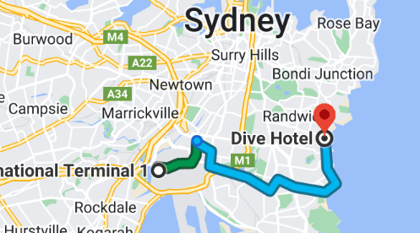

1. **Veriu Randwick**

* Walk to the Sydney International Airport Station (Platform 1).
* Take the T8 train towards City Circle via Museum.
* Travel until you reach Central Station. This will take about 11-13 minutes.
* Walk for about 4 minutes (300 meters) to transfer to Platform 3.
* Take the L2 light rail towards Randwick.
* Travel until you reach the Randwick Station. This will take approximately 18 minutes.
* After arriving at Randwick Station, walk for approximately 5 minutes (350 meters) to reach Veriu Randwick, located at 65-71 Belmore Rd, Randwick NSW 2031.

**Public Transport Directions from Hotel to Venue：**

**From Crowne Plaza Sydney Coogee Beach to John Niland Scientia Building:**

1. **Walk** for 7 minutes (550 meters) to the bus stop on Arden Street near Coogee Bay Road.
2. **Take the bus** (370) from Coogee Beach to High Street near UNSW (Gate 9).
   * Travel for 7 stops (approximately 13 minutes).
3. **Walk** for 7 minutes (550 meters) to the John Niland Scientia Building.

**From Dive Hotel to John Niland Scientia Building:**

1. **Walk** for 4 minutes (300 meters) to the bus stop on Coogee Bay Road near Arden Street.
2. **Take the bus** (370) from Coogee Beach to High Street near UNSW (Gate 9).
   * Travel for 7 stops (approximately 13 minutes).
3. **Walk** for 7 minutes (550 meters) to the John Niland Scientia Building.

**From Veriu Randwick to John Niland Scientia Building:**

1. **Head southeast on Belmore Rd** toward Avoca St. Walk along Belmore Rd for about 150 meters.
2. **Turn left onto Avoca St.** Follow Avoca St for about 450 meters.
3. **Turn right onto High St.** Continue walking along High St for approximately 850 meters. You will pass several university buildings as you get closer.
4. **Enter the UNSW campus** at the intersection of High St and Gate 9.
5. **Walk straight ahead** on University Mall. Follow the path for about 400 meters. The UNSW Library will be on your left (the tall building).
6. **Arrive at the John Niland Scientia Building** located at the top of the stairs.